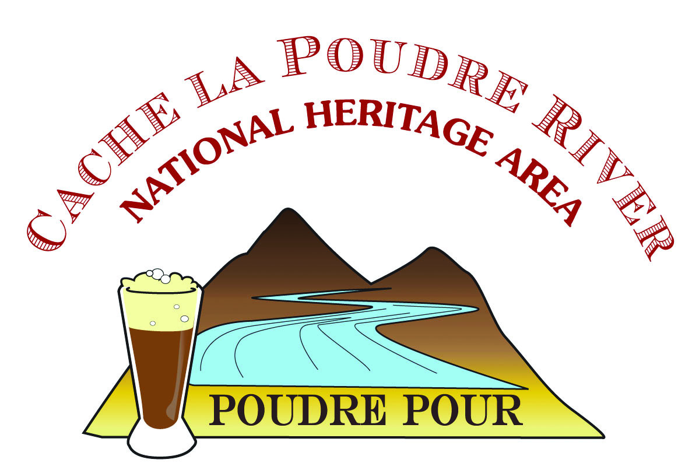**CABIN SPONSORSHIP**

POUDRE POUR 2019 • Saturday, March 30, 2019

Carnegie Center for Creativity • 12–4 pm

EXCLUSIVE OPPORTUNITY…

To be a featured presenter of an activity station inside one of the four historic cabins in the Heritage Courtyard at the Poudre Pour 2019.

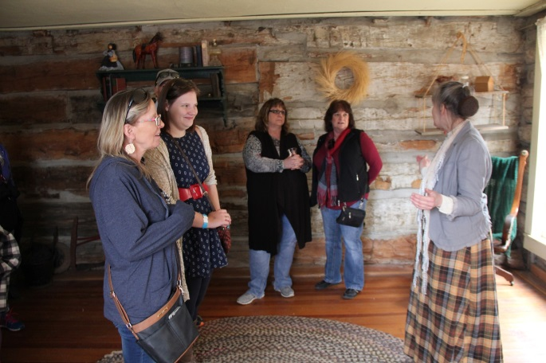**Available on first-come, first-served basis to sponsors at** **$1,500 River Water level and above.**

<https://poudreheritage.org/event/poudre-pour-2019/>

**Receive all the benefits of your chosen sponsorship level** **PLUS**:

* Name/logo on the cabin activity signage at event
* Consumer engagement (on-site, follow-up, give-aways)

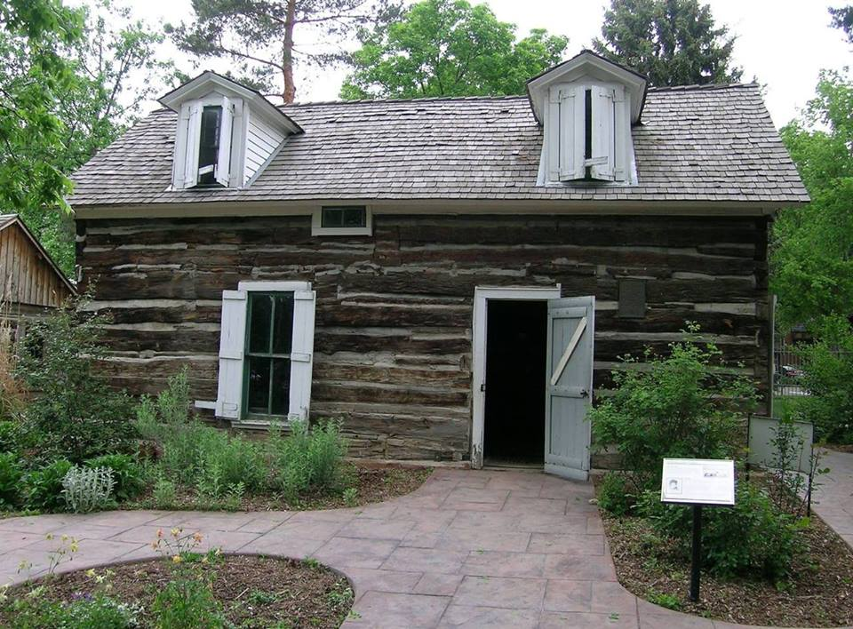

Host an activity station for youth and/or adults inside a historic cabin that aligns with the event’s themes – water, history, Poudre River, art & culture of the river corridor.

**Sample ideas include:**

* Historic costume photo “booth” (digital images emailed to attendees by sponsor)
* Water “Bingo” - small prizes
* Assess your personal water usage
* Water Trivia Wheel Game, small prizes
* 18th Century youth games such as Jackstraws or making corn husk dolls
* Spelling Bee focused on history, heritage, water, Poudre River
* Water science games

NOTE: *The cabins are historic museum exhibits and no food, drink, electricity are permitted inside.*

*Cabin Activities need to be approved by the Discovery Science Museum (coordinated by Poudre Heritage Alliance).*

